Ab initio molecular dynamics study of LiCl-KCl system

Kai Duemmler*, Benjamin Beeler*†, Yuxiao Lin†, Gorakh Pawar†, Ruchi Gahkar†

* Department of Nuclear Engineering, North Carolina State University, Raleigh, NC, 27695-7909, USA,
† Idaho National Laboratory, 2525 Fremont Ave, Idaho Falls, ID 83415

INTRODUCTION

Molten salts have long been considered for use in the nuclear industry both as a coolant and as a fuel system, and as a processing medium. The LiCl-KCl system is of interest to the nuclear community as it is used in the handling of spent nuclear fuel to remove actinides and other fission products [1]. Other uses for molten chloride salts such as LiCl-KCl is for heat storage material and as a heat transfer medium [2]. The purpose of this paper is to use ab initio molecular dynamics (AIMD) to simulate the properties of the entire LiCl-KCl molten salt system for a large range of temperatures. In particular, the properties of interest in this study are density, compressibility, and heat capacity. A study of diffusion properties has been carried out at 1200 K to look at heat capacity with constant volume, diffusivity and dynamic viscosity. The goal of this study is not to rely on interatomic potential molecular dynamic (IPMD) models to determine equilibrium properties [1]. Without the need for force fields, the accuracy of the simulations can be increased, with a consequence of increasing the computational cost.

Computational methods

In this study, AIMD is employed during equilibration and simulation via the Vienna ab initio Simulation Package (VASP) . The eutectic composition of LiCl-KCl is 58.5% LiCl and 41.5% KCl with a melting point of 361ºC [3]. The initial configuration was created in PyMatGen [4–6] with 200 atoms in total (43 Li atoms, 57 K atoms and 100 Cl atoms. This AIMD simulation as carried out in VASP [7–9], The vdW-DF2 Van der Waals functional is used for non-local correlation function to account for dispersion interactions [10]. An energy cutoff of 500 eV was utilized and the electronic optimization criterion was set to 10^-4 eV. Simulations were performed in an NVT ensemble, where temperature was controlled with a Langevin thermostat and the time step was 2.5 femtoseconds. The mixing parameters within VASP were optimized for convergence, yielding AMIX=0.5 with BMIX=0.1. A 1x1x1 k-point mesh was implemented at the gamma point due to computational restrictions, as has been demonstrated in the literature [12].
Initial melting of the structure was conducted at 2000 K for 15 ps, confirming that the radial distribution function indicated a liquid state. The system was then cooled to various target temperatures from 1000 to 1300 K, over 5 ps. The systems were equilibrated for another 10 ps to equilibrate at current volume. To find the equilibrium volume, the volume was perturbed and the pressure as a function of volume was determined. First, a coarse perturbation of volume is conducted and fit with a parabolic function to roughly find at which volume the pressure is zero. Then, a finer mesh is utilized to more precisely find at which volume the pressure is zero. An example of this is illustrated in Fig. 1. This parabolic fit can be used to calculate properties as seen in equation 1 and 2.
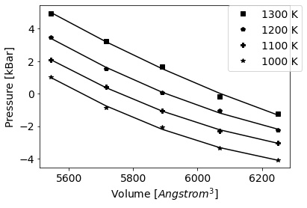Fig. 1. Pressure as a function of supercell volume. The equilibrium volume is the volume at which the pressure is zero.

Several useful properties of molten salts can be calculated from the pressure versus volume curves, including the bulk modulus and compressibility of the liquid, as seen in equations 1 and 2. Here K is the bulk modulus, V is the volume, P is the pressure, and β is the compressibility.

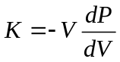 (1)
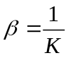 (2)

Another property that can be calculated is the heat capacity at constant pressure as seen in equation 3. Where E is the total energy and T is the absolute temperature. Similar to the pressure, the total energy of the system is tracked as a function of time and averaged over the final 4 ps of the simulation.

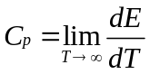 (3)
Diffusion Properties

The determination of diffusional properties requires the extension to much longer timescales. The time step for the diffusion properties was changed to 5 femtoseconds and the energy drift was verified to be less the 1 eV/Å. The systems were equilibrated for up to 100 ps, either in a single simulation or in a series of shorter time simulations. Once the system has reached equilibrium, the constant volume specific heat capacity can be calculated using equation 4, which uses the ensemble average of the variation in energy, k_{B} is the Boltzmann constant, and m is the mass of the system [13,14].

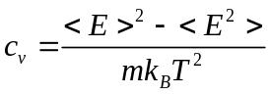 (4)

The self-diffusion coefficient (D) can be calculated for each ion based on the trajectories of the ions, and the Einstein relation can be used to evaluate this dynamic property, as seen in equation 5 [14,15],

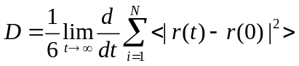 (5)

where N is the total number of atoms (which is 200 in this case), r(t) is the atom spatial coordinates at time t, and r(0) is the original position of that atom.
The viscosity can also be calculated from the trajectories and the Stokes-Einstein-Sutherland equation [12,13] as seen in equation 6.

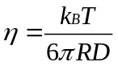 (6)

Where R is the solvodynamic radius of solute cation, which can be approximatied as the ionic radius [13].

Results and Disscussion

The density as a function of composition for each temperature is shown in Fig 2., with a comparison to the literature for 1100 K. The calculated densities nearly exactly match the experimental data collected by Wang et al. [16], but are slightly below the values calculated by Janz et al. [17]. However, this discrepancy with Janz deceases as the concentration of KCl increases. The density tends to increase as a function of KCl, exhibiting slightly positive deviations from linearity. As expected, the density decreases with increasing temperature. Finally, a comparison can be made to the Born-Mayer-Huggins interatomic potential employed in the classical molecular simulations by Wang et al. [16], which significantly underestimates the equilibrium density across the entire compositional range.
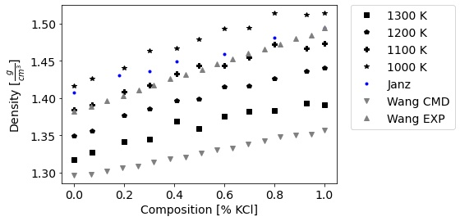
Fig. 2. Density vs the composition of LiCl-KCl. AIMD results are compared to classical molecular dynamics and experimental results from Wang et al. [16], and experimental results from Janz et al. [17].

The compressibility as a function of composition and temperature is shown in Fig. 3. This data displays significantly greater scatter than the density, however, general trends can still be extracted. As the temperature increases, the compressibility tends to increase. Similarly, the compressibility increases as the composition of KCl increases.
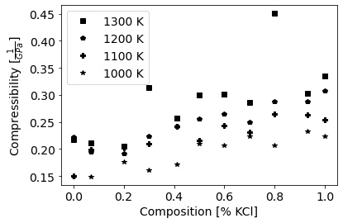
Fig. 3. The compressibility of the LiCl-KCl system as a function of composition and temperature.

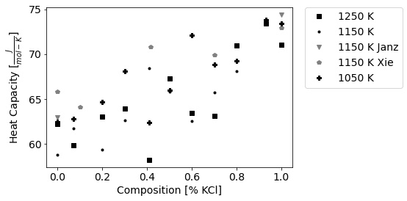
Fig. 4. Heat Capacity vs composition for LiCl-KCl system. Literature from [18,19]

The heat capacity as a function of composition and temperature is shown in Fig. 4. It can be observed that as the system becomes more KCl rich, the heat capacity tends to increase. Also, typically the smaller the temperature, the larger the heat capacity will be. It can be noted that the heat capacity values from AIMD are slightly under-predicting the experimental values of Janz [19] and Xie [18] by on average X%. This is considered reasonable agreement.

Diffusion Properties

In this section, the diffusion properties that were collected are presented for the 1200 K eutectic composition case that was studied. Four unique pathways were followed to obtain 100 ps trajectories: 10 simulations of 10 ps; four simulations of 25 ps; two simulations of 50 ps; and a single simulation of 100 ps. The results for the 100 ps simulation will be discussed first, followed by a comparison among the trajectories.

Utilizing the mean-squared displacement as a function of time and equation 5, the diffusivity as a function of time is determined and displayed Fig 5. It appears that the diffusivity has reached a converged value after approximately 80 ps. The resultant values for the diffusivity compared to previous computational work is shown in Table II.
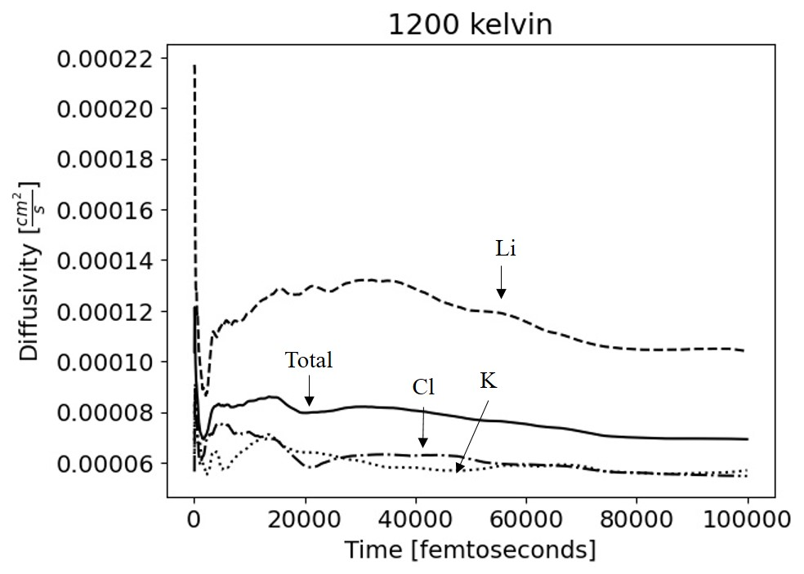
Fig. 5. Diffusivity of the atoms in LiCl-KCl at 1200 K at the eutectic composition.

Table II shows the diffusivity at 1200 K (or extrapolated to 1200 K) for the eutectic composition.
Source | Li | K | Cl | Total
[1E-5 cm²/s]
This Work | 6.35 | 10.9 | 5.75 |  | 7.34
Bengston [1] | 12.5 | 10.9 | 10.6 |  | 10.6
Caccamo [3] | 8.37 | 8.08 | 8.08 |  | 8.27
Song [12] | 12.9 | 10.7 | 7.0 |  | 9.51

One must note that all other shown cases are extrapolated to 1200K. Lithium’s differences can be explained by it being a light element which can move easier than the heavier two elements but this argument cannot explain the range visible in chlorines diffusivity.

The magnitude of the total diffusivity of LiCl-KCl, and the percent difference from the single 100 ps simulation, are shown in Table 1. The total diffusivity as calculated via the 25 and 50 ps trajectories are within 5% and 12%, respectively, of the value at 100 ps. Interestingly, the 10 ps simulations only vary by about 6% from the single 100 ps trajectory. This small error in the incremental 10 ps simulation series is believed to be due to noise and is likely not a valid option for moving forward as the simulation run length. Such a conclusion was drawn from the 100 ps trajectory. It appears that simulations with a length of 25 ps are sufficiently close to values of 100 ps that a series of 25 ps simulations can provide sufficient accuracy in determining diffusional properties. This claim is being further validated to ensure statistical significance of the findings.

TABLE I. Total Diffusivity of different length runs.
Run Length | Diffusivity [1E-5 cm²/s] | Percent Difference from 100 ps [%]
10ps | 7.81 |  | -6.33
25ps | 6.97 |  | 5.11
50ps | 6.46 |  | 11.97
100ps | 7.34 |  | -

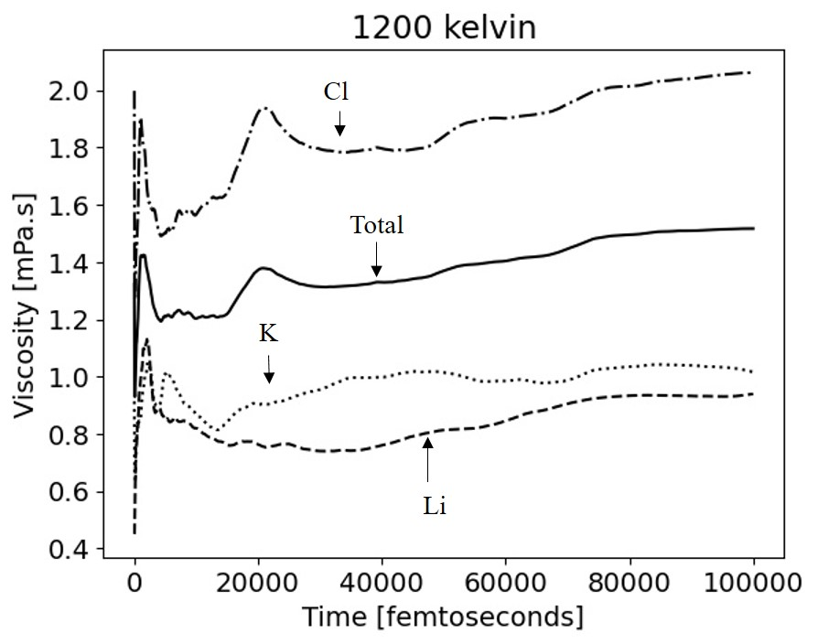
Fig. 6. Dynamic viscosity of eutectic LiCl-KCl at 1200 K with 200 atoms run in VASP.

The dynamic viscosity versus time can be seen in Fig. 6 and shows a slight oscillating behavior even in the 100 ps run. What can be gathered from this is that at 25 ps that values do not differ from the values at 100 picoseconds shown by the error in Table I and can be seen in Fig. 7.

The specific heat capacity at constant volume from the NVT run can be seen in Fig 7 at 1200K.
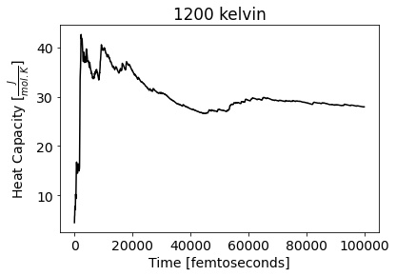
Fig. 7. Specific heat capacity as a function of time of the atoms in the 1200 K simulation of eutectic LiCl-KCl.

The specific heat capacity appears to converge to a given value starting around 40 ps.

Conclusion and Future Work

The focus of this study was to comprehensively investigate the properties of the LiCl-KCl system for the whole compositional spectrum over a wide range of temperatures within a purely AIMD framework. The reported properties include density, bulk modulus, compressibility, and heat capacity. The density agrees exceptionally well with the experimental literature at 1100 K, while the heat capacity appears to be slightly underestimated.
An additional study on the transport properties was carried out on eutectic LiCl-KCl at 1200 K, providing the heat capacity at constant volume, diffusivity, and viscosity. It was found that a series of four individual 25 ps simulations is sufficient to replicate a single 100 ps simulation. This allows for distribution of computational resources, allowing for accurate determination of transport properties with statistical significance from AIMD. The results for diffusivity of individual species displays reasonable agreement with previous computational studies.

This work will be expanded to determine the transport properties across the entire compositional spectrum of the LiCl-KCl system, as well as a function of temperature.

ACKNOWLEDGMENTS

This material is based upon work supported under an Integrated University Program Graduate Fellowship. This work is also supported through the INL Laboratory Directed Research and Development (LDRD) Program under DOE Idaho Operations Office Contract DE-AC07-05ID14517. This research made use of the resources of the High-Performance Computing Center at Idaho National Laboratory, which is supported by the Office of Nuclear Energy of the U.S. Department of Energy and the Nuclear Science User Facilities.

REFERENCES

1. A. BENGSTON, “First-Principles Molecular Dynamics Modeling of the LiCl-KCl Molten System,” Comput. Mater. Sci., 83, 362 (2014).
2. G.-C. PAN, “Molecular simulations of the thermal and transport properties of alkali chloride salts for high-temperature thermal energy storage,” Int. J. Heat Mass Transf., 103, 417 (2016).
3. C. CACCAMO, “Molten alkali-halide mixtures: a molecular-dynamics study of Li/KCl mixtures,” J. Phys. C Solid State Phys., 13, 1887 (1980).
4. A. JAIN, “Commentary: The Materials Project: A materials genome approach to accelerating materials innovation,” APL Mater., 1, 110002 (2013).
5. S.P. ONG., “The Materials Application Programming Interface (API): A simple, flexible and efficient API for materials data based on REpresentational State Transfer (REST) principles,”Comput. Mater. Sci., 97, 209 (2015).
6. A. JAIN, “A high-throughput infrastructure for density functional theory calculations,” Comput. Mater. Sci., 50, 2295 (2011).
7. G. KRESSE, “Efficiency of ab-initio total energy calculations for metals and semiconductors using a plane-wave basis set,” Comput. Mater. Sci., 6, 15 (1996).
8. G. KRESSE, “Ab initio molecular dynamics for liquid metals,” Phys. Rev. B., 43, 558 (1993).
9. G. KRESSE, “Efficient iterative schemes for ab initio total-energy calculations using a plane-wave basis set,” Phys. Rev. B., 54, 11169 (1996).
10. M. DION, “Van der Waals Density Functional for General Geometries,” Phys. Rev. Lett., 92, 246401 (2004).
11. K. LEE, “Higher-accuracy van der Waals density functional,” Phys. Rev. B., 82, 81101 (2010).
12. J. SONG, “Towards the calculations of redox potentials in molten LiCl-KCl eutectic by ensemble averages based on first principles molecular dynamics, Electrochim,”Acta., 248, 462 (2017).
13. Z. RONG, “Ab-initio molecular dynamics calculation on microstructures and thermophysical properties of NaCl–CaCl2–MgCl2 for concentrating solar power,” Sol. Energy Mater. Sol. Cells., 216, 110696 (2020).
14. L.H. XIONG, “Evolution of atomic structure in Al75Cu25 liquid from experimental and ab initio molecular dynamics simulation studies,” J. Phys. Condens. Matter, 27, 35102 (2014).
15. W. LIANG, “First-principles molecular dynamics simulations on the local structure and thermo-kinetic properties of molten magnesium chloride,” J. Mol. Liq, 298, 112063 (2020).
16. J. WANG, “Molecular dynamics study of the transport properties and local structures of molten binary systems (Li, Na)Cl, (Li, K)Cl and (Na, K)Cl,” J. Mol. Liq, 209, 498 (2015).
17. G. J. JANZ, Thermodynamic and Transport Properties of Molten Salts: Correlation Equations for Critically Evaluated Density, Surface Tension, Electrical Conductance, and Viscosity Data, J. Phys. Chem. Ref. Data, 17, Suppl. 2 (1988).
18. W. XIE, Heat and mass transportation properties of binary chloride salt as a high-temperature heat storage and transfer media, Sol. Energy Mater. Sol. Cells, 209, 110415 (2020).
19. G. J. JANZ, Molten Salts: Volume 4, Part 1, Fluorides and Mixtures Electrical Conductance, Density, Viscosity, and Surface Tension Data, J. Phys. Chem. Ref. Data, 3, 1 (1974).

